Сделал Альбертович Богдан 0907-42
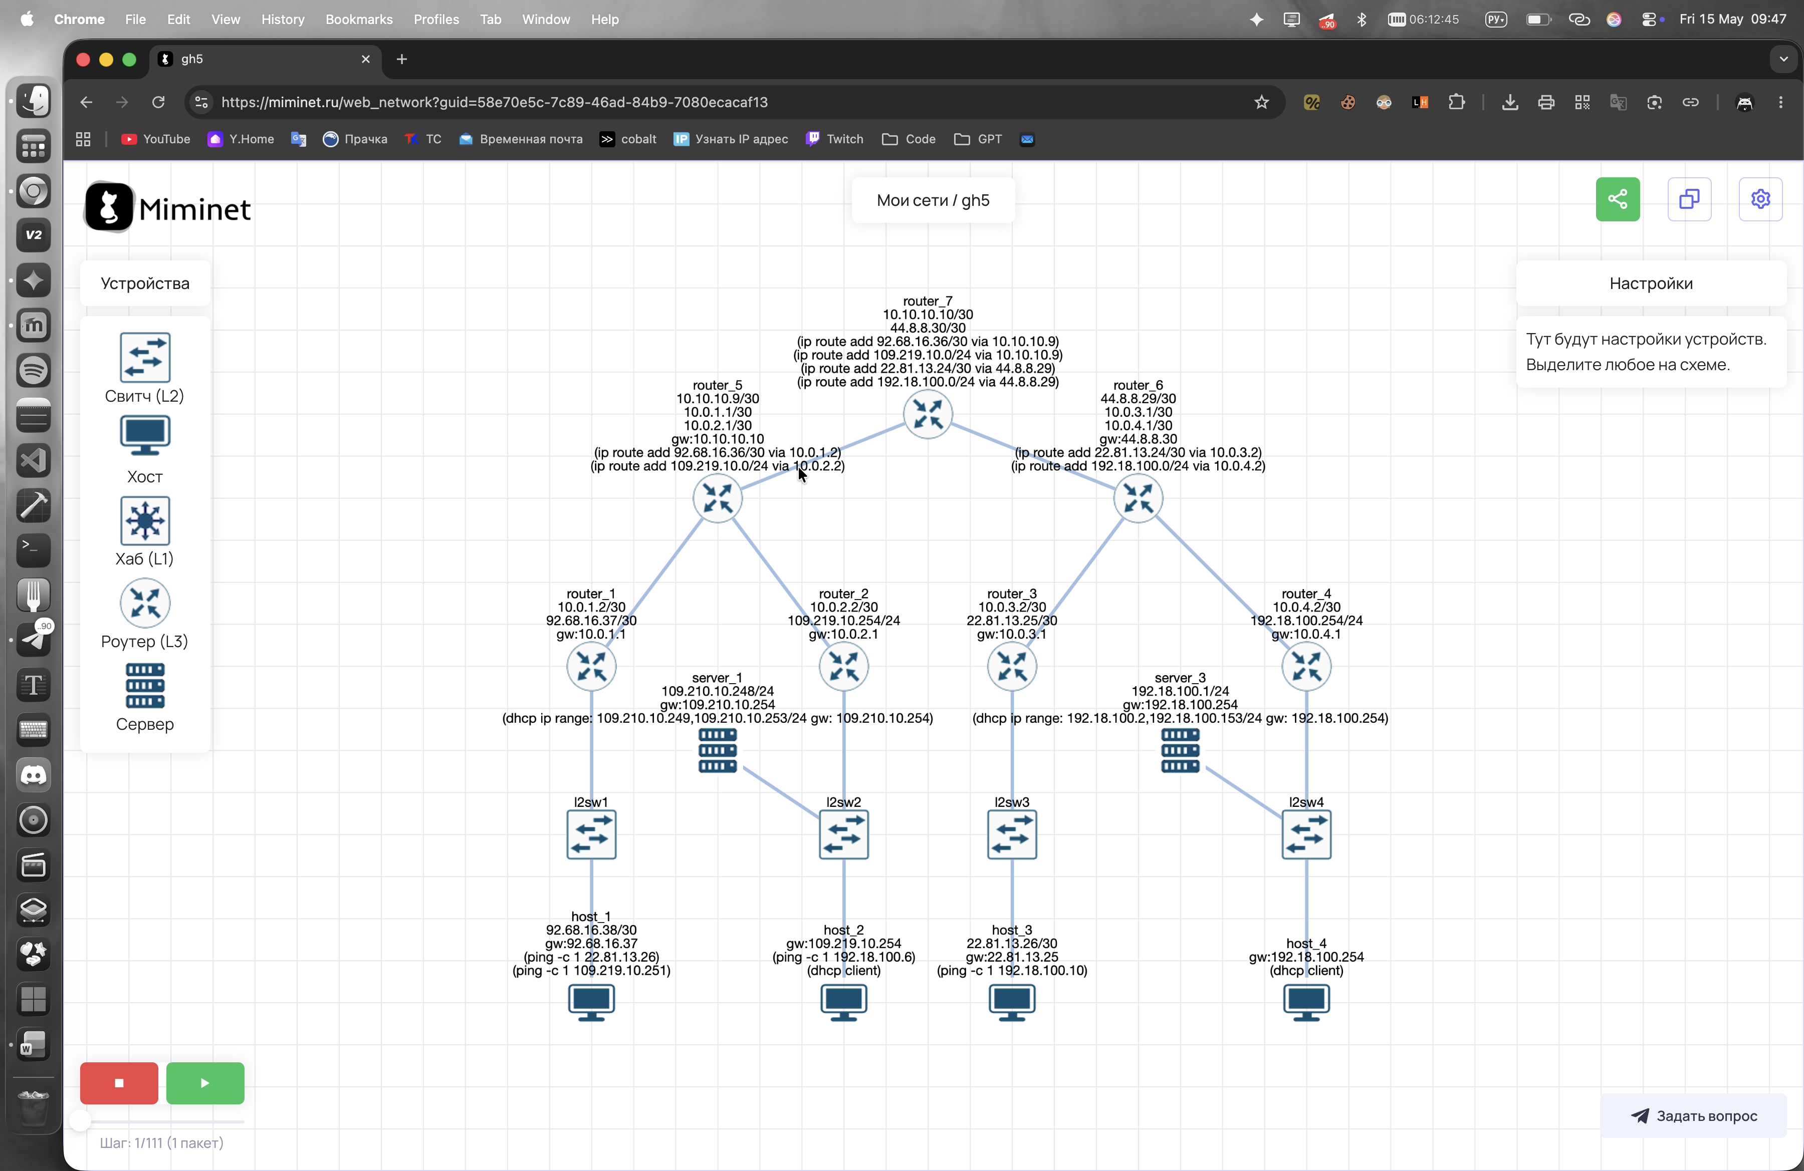
Устройство | MAC-адрес | IP-адрес
host1 | 00:00:00:00:00:01 | 92.68.16.38
host2 | 00:00:00:00:00:02 | 109.210.10.251
host3 | 00:00:00:00:00:03 | 22.81.13.26
host4 | 00:00:00:00:00:04 | 192.18.100.6
router1 | 12:78:f0:90:c1:82 | 92.68.16.37
router2 | 22:5f:2d:d0:25:90 | 10.0.2.2
router3 | 9e:37:e6:c8:c3 | 10.0.3.2
router4 | 96:0b:39:07:96:1d | 10.0.4.2
router5 | 8a:21:83:e1:3a:b9 | 10.0.1.1
router6 | 52:3e:14:51:5e:55 | 44.8.7.29
router7 | c2:d2:90:c2:2b:d9 | 10.10.10.10
server1 | 00:00:00:00:00:07 | 109.210.10.248
server2 | 00:00:00:00:00:06 | 192.18.100.254

